APUSH Time Period #3 1754 to 1800
British imperial attempts to reassert control over its colonies and the colonial reaction
to these attempts produced a new American republic, along with struggles over the new nation’s social, political, and economic identity.

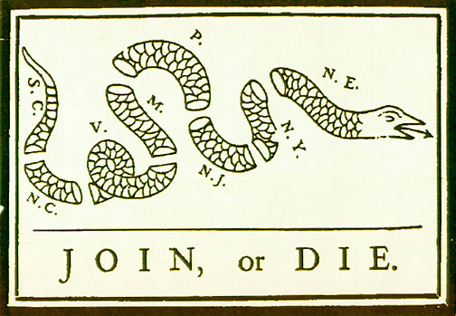  Albany Plan of Union | 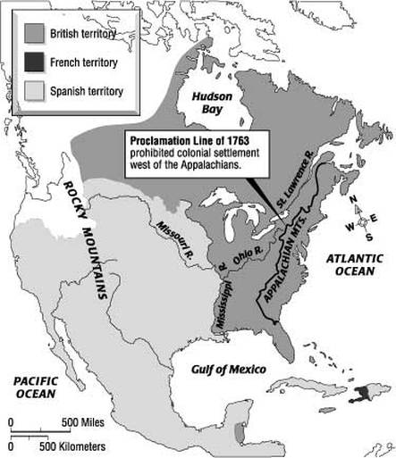  Proclamation of 1763 | 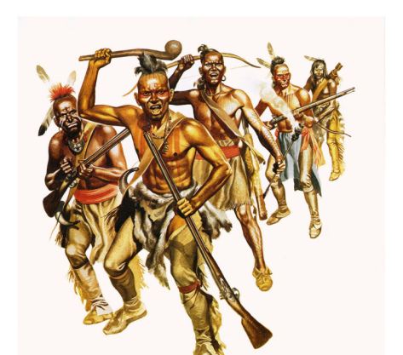  Pontiacs Rebellion
  The Stamp Act | 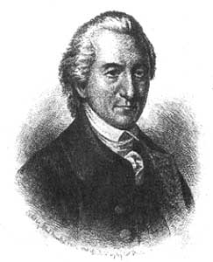  John Dickinson | 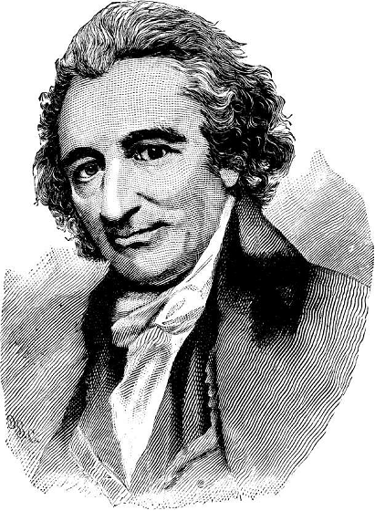  Thomas Paine
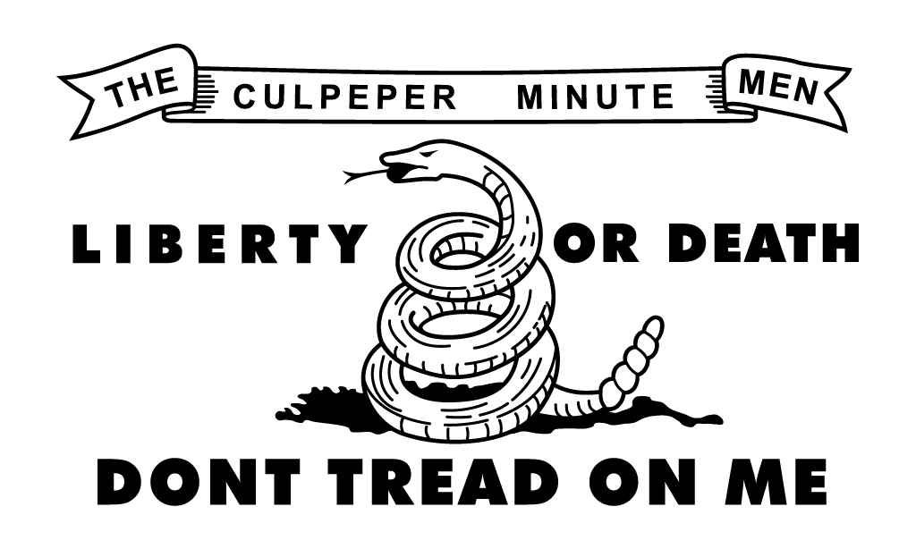  The American Revolution | 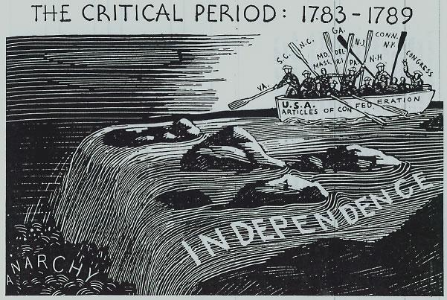  Articles of Confederation | 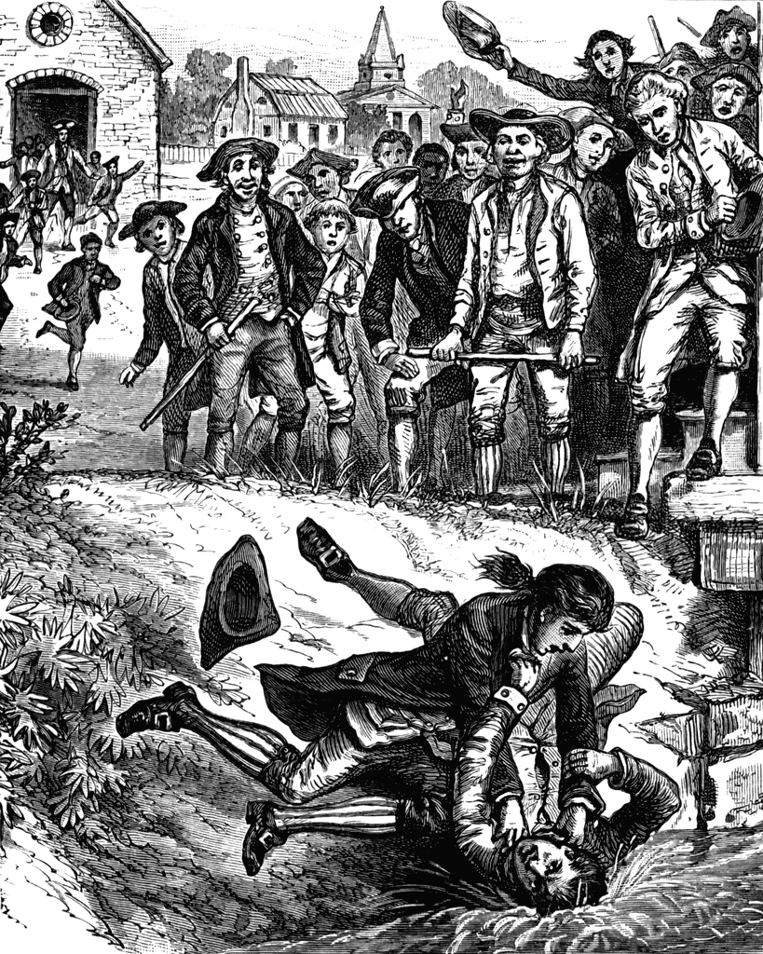  Shays’s Rebellion
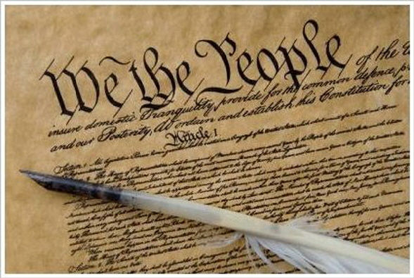  US Constitution | 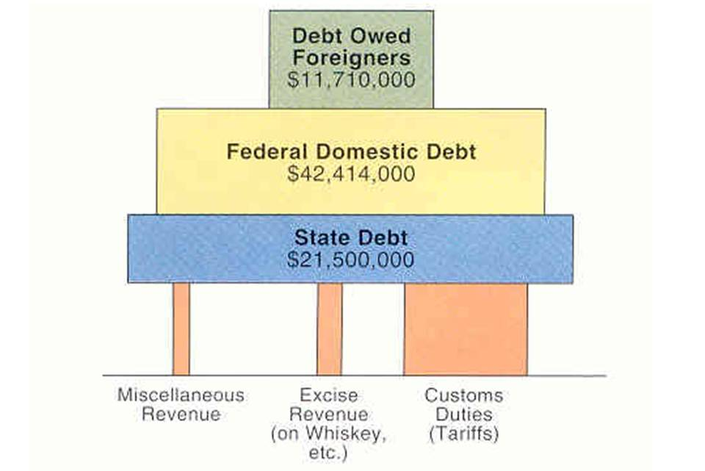  Hamilton’s Financial Plan | 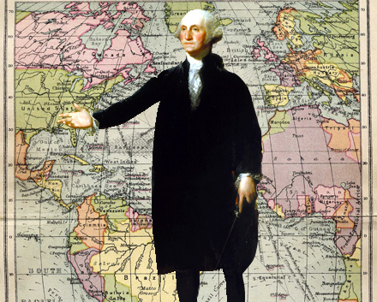Washington’s Farewell

NOTES – QUESTIONS- CONCERNS

Chapter #6
The Duel for North America

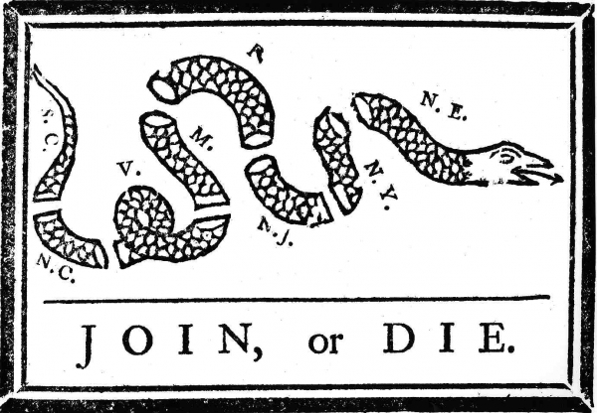

Chapter Synopsis: As the seventeenth century neared its sunset, a titanic struggle was shaping up for mastery of the North American continent. The contest involved three Old World Nations—Britain,* France, and Spain—and it unavoidably swept up Native American peoples as well. From 1688 to 1763, four bitter wars convulsed Europe. All four of those conflicts were world wars. They amounted to a death struggle for domination in Europe as well as in the New World, and they were fought on the waters and soil of two hemispheres. Counting these first four clashes, nine world wars have been waged since 1688. The American people, whether as British subjects or as American citizens, proved unable to stay out of a single one of them. And one of those wars— known as the Seven Years’ War in Europe and the French and Indian War in America—set the stage for America’s independence.

Please provide TWO key points that can be drawn from the chapter synopsis.
KEY POINT #1
KEY POINT #2

Guided Readings: Chapter #6 The Duel for North America

The Clash of Empires  1. Describe the early wars between France and Britain.  George Washington Inaugurates War with France  2. How did George Washington spark the French and Indian War?  Global War and Colonial Disunity  Know: Benjamin Franklin, Albany Plan of Union, "Join or Die"  3. What was meant by the statement, “America was conquered in Germany?  Braddock's Blundering and Its Aftermath  4. What setbacks did the British suffer in the early years of the French and Indian War?  Pitt's Palms of Victory  5. What was the significance of the British victory in the French and Indian War?  6. Restless Colonials  War’s Fateful Aftermath  7. How did French defeat lead to westward expansion and tension with Native Americans and the British? | COMMENTS, CONCERNS or CLARIFICATIONS  COMMENTS, CONCERNS or CLARIFICATIONS
  Explain the subheading

Chapter #7
The Road to Revolution

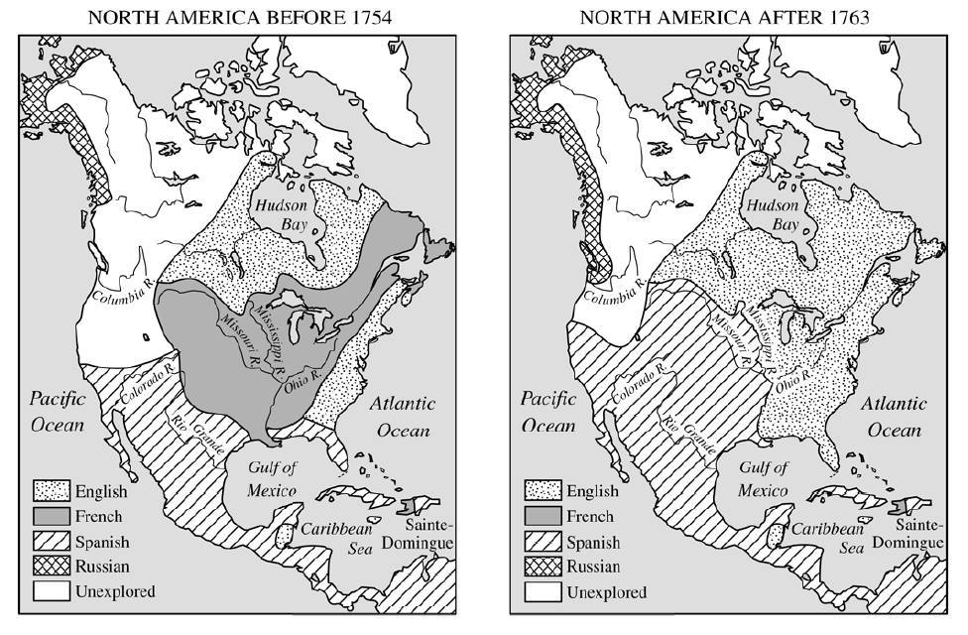

Chapter Synopsis: Victory in the Seven Years’ War made Britain the master of a vastly enlarged imperial domain in North America. But victory—including the subsequent need to garrison ten thousand troops along the sprawling American frontier—was painfully costly. The London government therefore struggled after 1763 to compel the American colonists to shoulder some of the financial costs of empire. This change in British colonial policy reinforced an emerging sense of American political identity and helped to precipitate the American Revolution. The eventual conflict was by no means inevitable. Indeed, given the tightening commercial, military, and cultural bonds between colonies and mother country since the first crud settlements a century and a half earlier, it might be considered remarkable that the Revolution happened at all. The truth is that Americans were reluctant revolutionaries. Until late in the the day, they sought only to claim the “rights of Englishmen,” not to separate from the mother country. But what began as a squabble about economic policies soon exposed irreconcilable differences between Americans and Britons over cherished political principles.

Please provide TWO key points that can be drawn from the chapter synopsis.
KEY POINT #1
KEY POINT #2

Guided Readings - Chapter #7 The Road to Revolution
The Deep Roots of Revolution  1. Why does the author say that the American Revolution began when the first settlers stepped ashore?  Mercantilism and Colonial Grievances  2. Explain the economic theory of mercantilism and the role of colonies.  3. The Merits and Menace of Mercantilism  4. What economic factors were involved in leading colonists to be displeased with the British government?  5. The Stamp Tax Uproar  The Townshend Tea Tax and the Boston "Massacre"  6. How did the Townshend Acts lead to more difficulties?  Tea Brewing in Boston  7. What was the cause of the Boston Tea Party, and what was its significance?  8. Parliament Passes the "Intolerable Acts"  Bloodshed  9 . What was the goal of the First Continental Congress?  Imperial Strength and Weakness  10. What were British strengths and weaknesses at the outset of the war?  American Pluses and Minuses  11. What were the American strengths and weaknesses at the outset of the war?  12. A Thin Line of Heroes | COMMENTS, CONCERNS or CLARIFICATIONS  COMMENTS, CONCERNS or CLARIFICATIONS  COMMENTS, CONCERNS or CLARIFICATIONS  COMMENTS, CONCERNS or CLARIFICATIONS
  Explain the Subheading
  Explain the Subheading
  Explain the Subheading
  Explain the Subheading

Chapter #8
American Secedes from the Empire

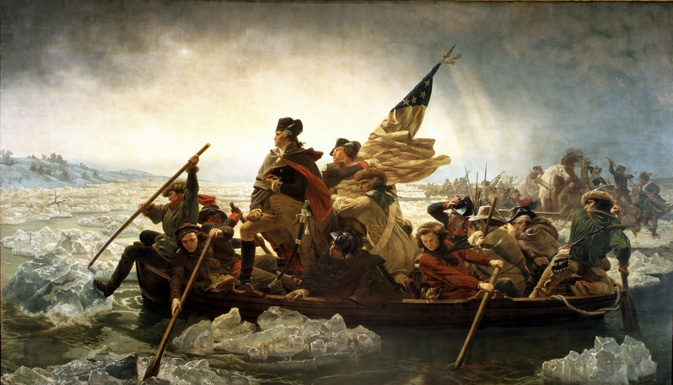

Chapter Synopsis: Bloodshed at Lexington and Concord in April of 1775 was a clarion call to arms. About twenty thousand musket-bearing “Minute Men’’ swarmed around Boston, there to coop up the outnumbered British. The Second Continental Congress met in Philadelphia the next month, on May 10, 1775, and this time the full slate of thirteen colonies was represented. The conservative element in Congress was still strong, despite the shooting in Massachusetts. There was still no well-defined sentiment for independence— merely a desire to continue fighting in the hope that the king and Parliament would consent to a redress of grievances. Congress hopefully drafted new appeals to the British people and king—appeals that were spurned. Anticipating a possible rebuff, the delegates also adopted measures to raise money and to create an army and a navy. The British and the Americans now teetered on the brink of all-out warfare.

Please provide TWO key points that can be drawn from the chapter synopsis.
KEY POINT #1
KEY POINT #2

Guided Reading Chapter #8 American Secedes from the Empire
Congress Drafts George Washington  1. Why was George Washington chosen as general of the American army?  2. Thomas Paine Preaches Common Sense and "Republicanism"  Jefferson's "Explanation" of Independence  3. What does the Declaration of Independence say?  4. Patriots and Loyalists  The Loyalist Exodus  5. What happened to Loyalists during the war?  Burgoyne's Blundering Invasion  6. Why did the Americans win the battle of Saratoga? Why was it significant?  Revolution in Diplomacy?  7. Why did the French help America win independence?  The Colonial War Becomes a Wider War  8. Why was foreign aid so important to the American cause?  The Land Frontier and the Sea Frontier  9. Was frontier fighting important in the outcome of the war?  Peace at Paris  10. What did America gain and what did it concede in the Treaty of Paris? | COMMENTS, CONCERNS or CLARIFICATIONS  COMMENTS, CONCERNS or CLARIFICATIONS  COMMENTS, CONCERNS or CLARIFICATIONS
  Explain the Subheading
  Explain the Subheading
Chapter #9
The Confederation and the Constitution

Chapter Synopsis: The American Revolution was not a revolution in the sense of a radical or total change. It did not suddenly and violently overturn the entire political and social framework, as later occurred in the French and Russian Revolutions. What happened was accelerated evolution rather than outright revolution. During the conflict itself, people went on working and praying, marrying and playing. Many of them were not seriously disturbed by the actual fighting, and the most isolated communities scarcely knew that a war was on. Yet some striking changes were ushered in, affecting social customs, political institutions, and ideas about society, government, and even gender roles. The exodus of some eighty thousand substantial Loyalists robbed the new ship of state of conservative ballast. This weakening of the aristocratic upper crust, with all its culture and elegance, paved the way for new, Patriot elites to emerge. It also cleared the field for more egalitarian ideas to sweep across the land.

Please provide TWO key points that can be drawn from the chapter synopsis.
KEY POINT #1
KEY POINT #2

Guided Readings - Chapter #9 Confederation to Constitution
The Pursuit of Equality  1. What social changes resulted from the American Revolution?  Constitution Making in the States  2. What was the importance of the state constitutions?  3. A Shaky Start toward Union  Creating a Confederation  4. What forces served to unify the separate states during the war?  5. The Articles of Confederation: America's First Constitution  Landmarks in Land Laws  6. Explain the importance of the Land Ordinance of 1785 and the  Northwest Ordinance.  7. The Horrid Specter of Anarchy  A Convention of "Demigods"  8. What kind of men gathered in Philadelphia for the "sole and express purpose of revising" the old government?  8. Hammering out a Bundle of Compromises  Safeguards for Conservatism  9.How democratic was the Constitution as originally written?  The Clash of Federalists and Anti- federalists  10. Who were the anti- federalists and why did they oppose the Constitution?  The Four Laggard States  11. Explain some of the opposition to ratification of the Constitution. | COMMENTS, CONCERNS or CLARIFICATIONS  COMMENTS, CONCERNS or CLARIFICATIONS  COMMENTS, CONCERNS or CLARIFICATIONS  COMMENTS, CONCERNS or CLARIFICATIONS
  Explain the Subheading
  Explain the Subheading
  Explain the Subheading
  Explain the Subheading

Chapter #10
Launching the New Ship of State

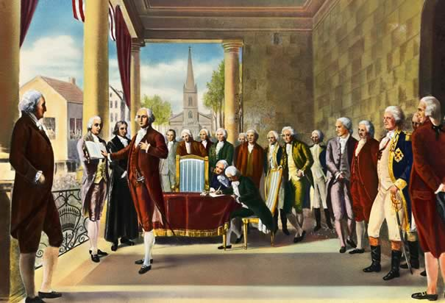

Chapter Synopsis: America’s new ship of state did not spread its sails to the most favorable breezes. Within twelve troubled years, the American people had risen up and thrown overboard both the British yoke and the Articles of Confederation. A decade of lawbreaking and constitution smashing was not the best training for government making. Americans had come to regard a central authority, replacing that of George III, as a necessary evil—something to be distrusted, watched, and curbed. Finances of the infant government were likewise precarious. The revenue had declined to a trickle, whereas the public debt, with interest heavily in arrears, was mountainous. Worthless paper money, both state and national, was as plentiful as metallic money was scarce. Nonetheless, the Americans were brashly trying to erect a republic on an immense scale, something that no other people had attempted and that traditional political theory deemed impossible. The eyes of a skeptical world were on the upstart United States.

Please provide TWO key points that can be drawn from the chapter synopsis.
KEY POINT #1
KEY POINT #2

Guided Reading - Chapter #10 Launching the New Ship of State
Washington for President  1. Was Washington an important president? Explain.  The Bill of Rights  2. What important steps were taken by the first congress?  Hamilton Revives the Corpse of Public Credit  3. How did Alexander Hamilton's economic plans lead to the District of Columbia?  4. Customs Duties and Excise Taxes  Hamilton Battles Jefferson for a Bank  5. How did the issue of the Bank of the United States reveal a difference in understanding about the Constitution between Jefferson and Hamilton?  6. Mutinous Moonshiners in Pennsylvania  The Emergence of Political Parties  7. Why did political parties develop during George Washington's presidency? Were they good or bad?  The Impact of the French Revolution  8. In what way did the French Revolution expose the differing views of Democratic-Republicans and Federalists?  9. Washington's Neutrality Proclamation  Embroilments with Britain  10. How did British actions towards Native Americans and American merchant ships incite many Americans?  11. Jay's Treaty and Washington's Farewell  Unofficial Fighting with France  12.What French actions brought America close to war in the closing years of the 18th century?  Adams Puts Patriotism above Party  13. How did avoiding war with France hurt John Adams' political career?  14. The Federalist Witch Hunt and The Virginia (Madison) and Kentucky (Jefferson) Resolutions | COMMENTS, CONCERNS or CLARIFICATIONS  COMMENTS, CONCERNS or CLARIFICATIONS  COMMENTS, CONCERNS or CLARIFICATIONS  COMMENTS, CONCERNS or CLARIFICATIONS  COMMENTS, CONCERNS or CLARIFICATIONS
  Explain the Subheading
  Explain the Subheading
  Explain the Subheading
  Explain the Subheading
  Explain the subheading

Historical Thinking Skills - Time Period #3 1754 -1800

Directions: Please answer the following questions based on Chapters #3, 4, and 5 as well as class notes class discussions

3.1 Contextualization - In which ways did the Seven Years War change the balance of power in North America and throughout the world?

3.2 Historical Argumentation - To what degree and in which ways did British attempts to assert control over the colonies contribute to colonial revolt?

3.3 Contextualization - Explain the reasons for discontent among backcountry colonists and the manifestation of that discontent

3.4 Comparison Compare and contrast the beliefs of the Federalists and Republicans in the 1790's

3.4 Historical Argumentation Analyze the foreign policy issues facing the nation in the 1790's and evaluate the relative success of the United States in dealing with these problems

3.5 Periodization - To what degree was the election of 1800 a turning point in United States History? Defend your position

